**What is agent? Categorize and explain various types of agents in AI?**

An agent is a collection of sensors and actuators and which do something for us. An agent can a simple computer program, robotic car, vacuum cleaner etc.

Types of AI Agents

Agents can be grouped into five classes based on their degree of perceived intelligence and capability. All these agents can improve their performance and generate better action over the time. These are given below:

* Simple Reflex Agent
* Model-based reflex agent
* Goal-based agents
* Utility-based agent
* Learning agent

1. Simple Reflex agent:

* The Simple reflex agents are the simplest agents. These agents take decisions on the basis of the current percepts and ignore the rest of the percept history.
* These agents only succeed in the fully observable environment.
* The Simple reflex agent does not consider any part of percepts history during their decision and action process.
* The Simple reflex agent works on Condition-action rule, which means it maps the current state to action. Such as a Room Cleaner agent, it works only if there is dirt in the room.
* Problems for the simple reflex agent design approach:
  + They have very limited intelligence
  + They do not have knowledge of non-perceptual parts of the current state
  + Mostly too big to generate and to store.
  + Not adaptive to changes in the environment.

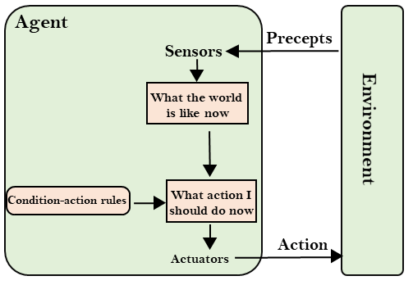

2. Model-based reflex agent

* The Model-based agent can work in a partially observable environment, and track the situation.
* A model-based agent has two important factors:
  + **Model:** It is knowledge about "how things happen in the world," so it is called a Model-based agent.
  + **Internal State:** It is a representation of the current state based on percept history.
* These agents have the model, "which is knowledge of the world" and based on the model they perform actions.
* Updating the agent state requires information about:
  + How the world evolves
  + How the agent's action affects the world.

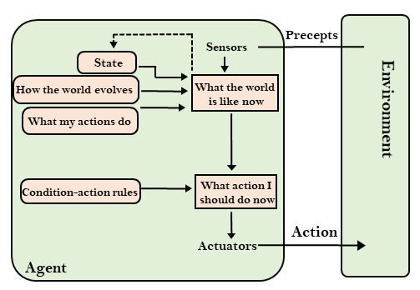

3. Goal-based agents

* The knowledge of the current state environment is not always sufficient to decide for an agent to what to do.
* The agent needs to know its goal which describes desirable situations.
* Goal-based agents expand the capabilities of the model-based agent by having the "goal" information.
* They choose an action, so that they can achieve the goal.
* These agents may have to consider a long sequence of possible actions before deciding whether the goal is achieved or not. Such considerations of different scenario are called searching and planning, which makes an agent proactive.

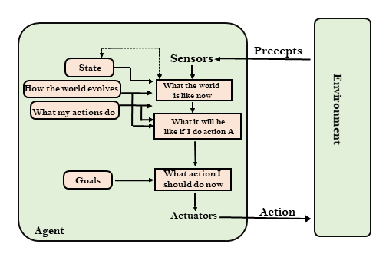

4. Utility-based agents

* These agents are similar to the goal-based agent but provide an extra component of utility measurement which makes them different by providing a measure of success at a given state.
* Utility-based agent act based not only goals but also the best way to achieve the goal.
* The Utility-based agent is useful when there are multiple possible alternatives, and an agent has to choose in order to perform the best action.
* The utility function maps each state to a real number to check how efficiently each action achieves the goals.

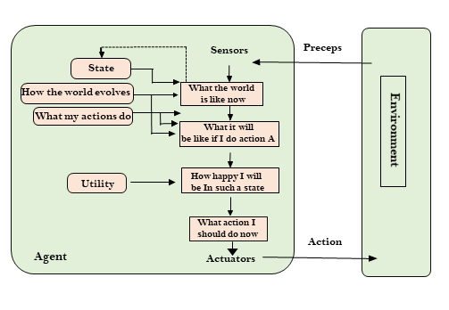

5. Learning Agents

* A learning agent in AI is the type of agent which can learn from its past experiences, or it has learning capabilities.
* It starts to act with basic knowledge and then able to act and adapt automatically through learning.
* A learning agent has mainly four conceptual components, which are:
  1. **Learning element:** It is responsible for making improvements by learning from environment
  2. **Critic:** Learning element takes feedback from critic which describes that how well the agent is doing with respect to a fixed performance standard.
  3. **Performance element:** It is responsible for selecting external action
  4. **Problem generator:** This component is responsible for suggesting actions that will lead to new and informative experiences.
* Hence, learning agents are able to learn, analyze performance, and look for new ways to improve the performance.

